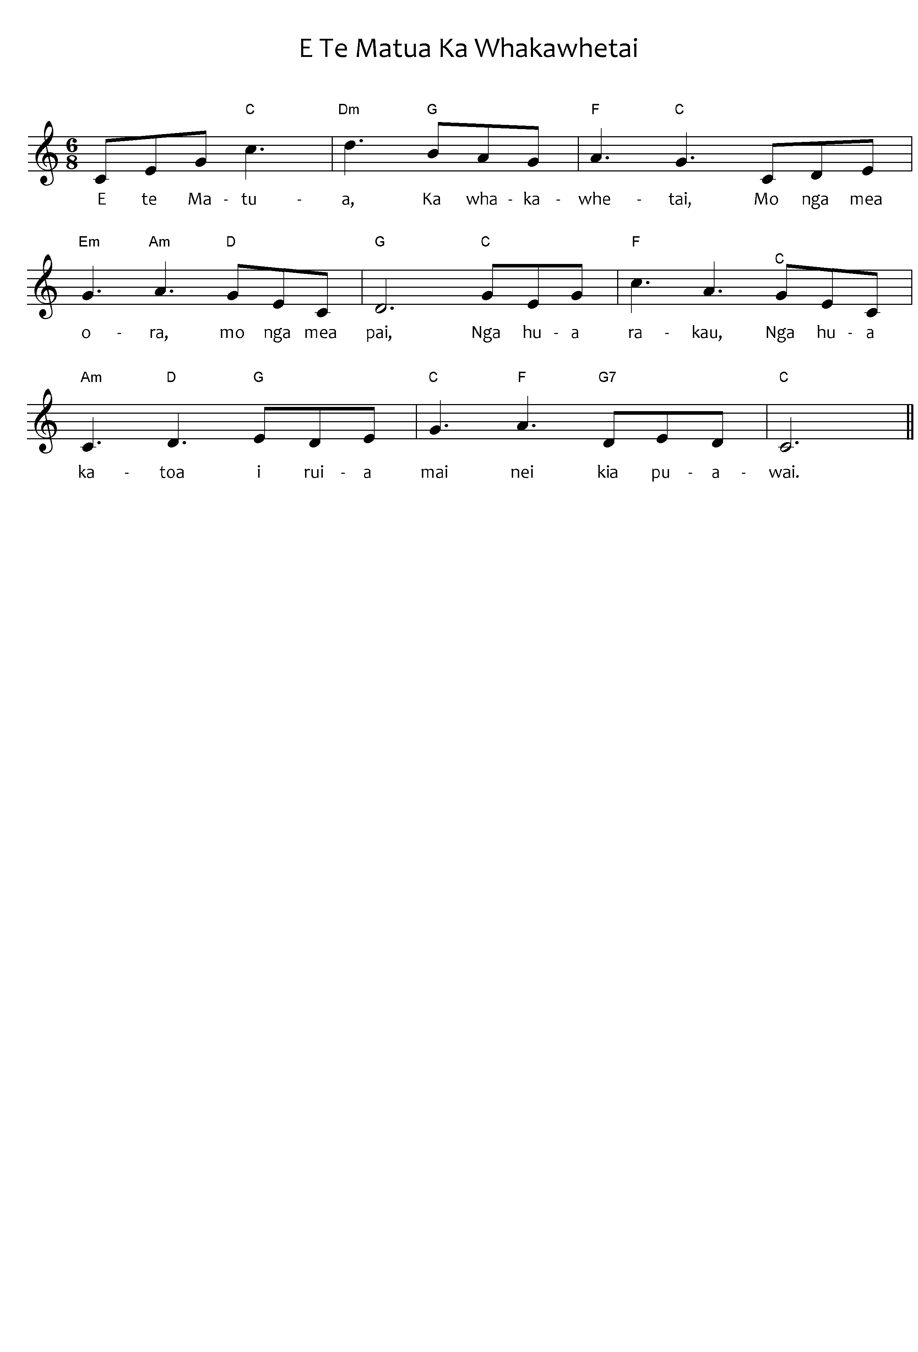

***Please note:*** the tohutō (macrons) are important, as they indicate correct pronunciation. Please ensure when you copy words that the tohutō are in place as indicated by the text written below the music on this page. The music writing program used for the sheet music does not allow the inclusion of tohutō.

The translation is not intended to be sung.

When singing Waiata in your parish / faith community, please always include the translation so people can know what they are singing.

Father

Thank you

For living things

For all that is good

Fruit trees

And their fruit

That were sown

And bloom

E te Matua

Ka whakawhetai

Mo ngā mea ora

Mo ngā mea pai.

Ngā hua rākau

Ngā hua katoa

I ruia mai nei kia puawai.

*E Te Matua Ka Whakawhetai - composer (words) unknown,*

*tune, Traditional Gaelic (Morning Has Broken), Public Domain*

*Ngā Hīmene 50*