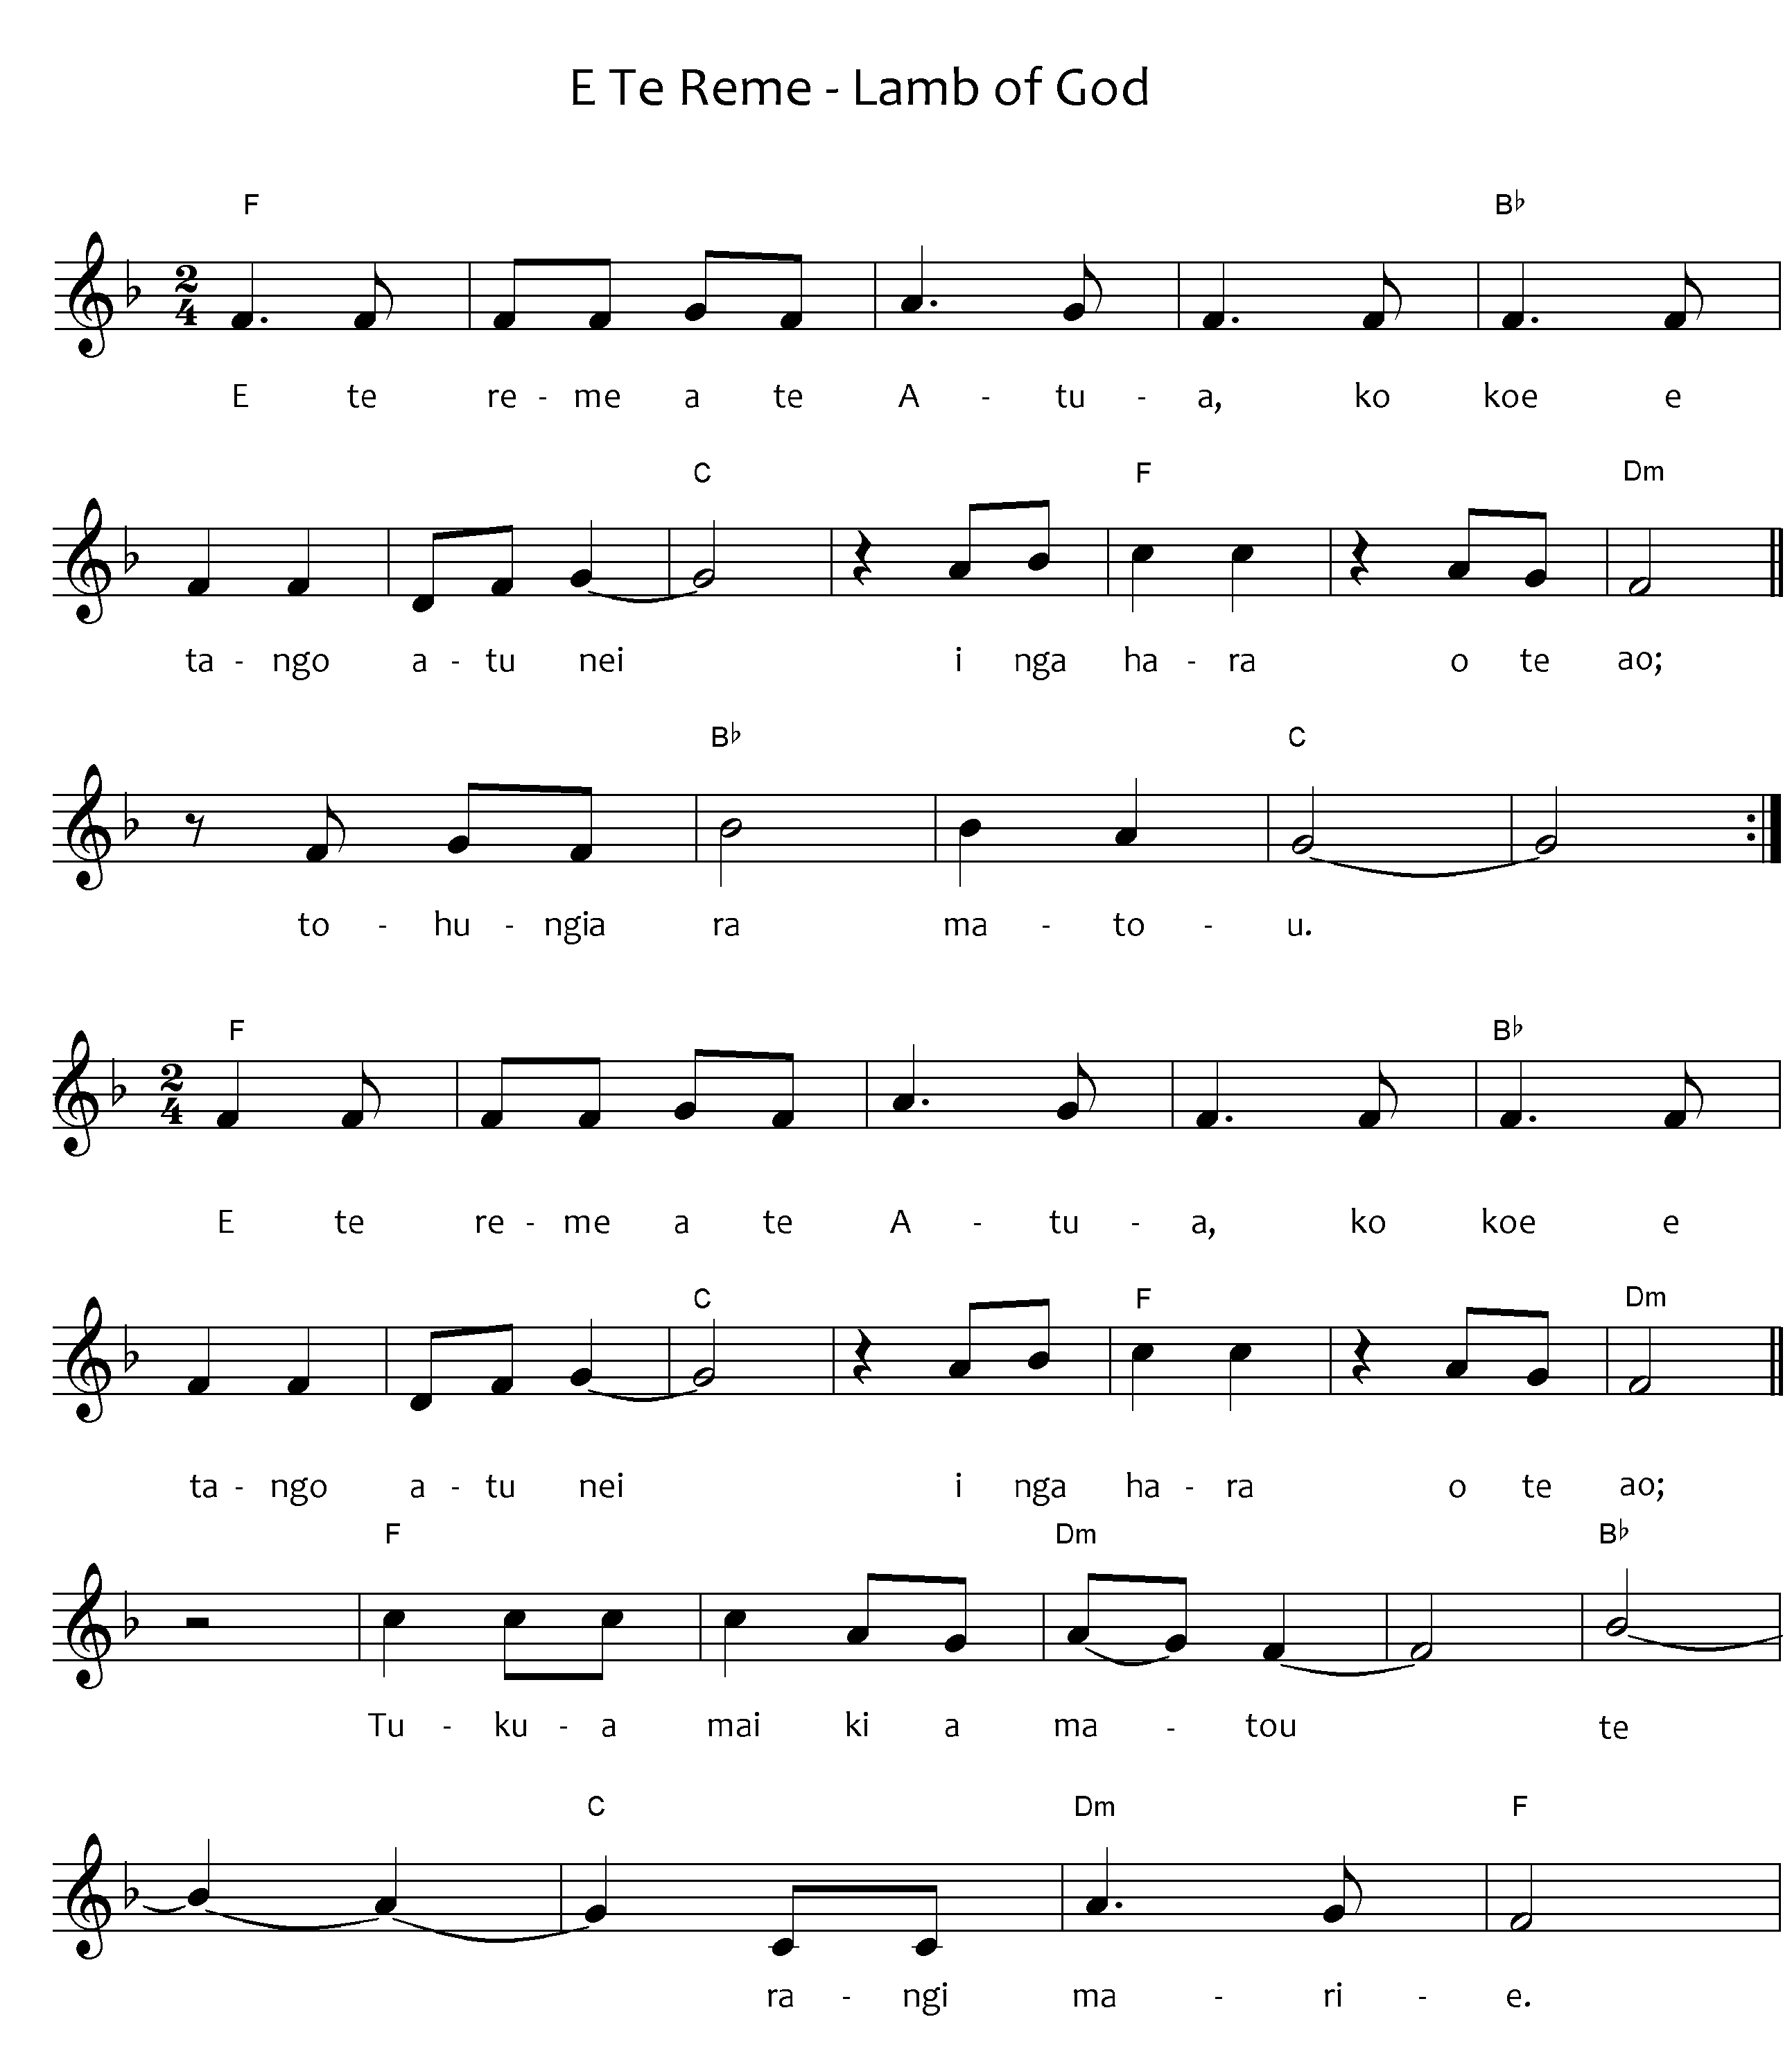

Please note: the tohutō (macrons) are important, as they indicate correct pronunciation. Please ensure when you copy words that the tohutō are in place as indicated by the text written below the music on this page. The music writing program used for the sheet music does not allow the inclusion of tohutō.
The translation is not intended to be sung.
When singing Waiata in your parish / faith community, please always include the translation so people can know what they are singing.

E te reme a te Atua, ko koe e tango atu nei, i ngā hara o te ao, tohungia rā mātou.
E te reme a te Atua, ko koe e tango atu nei, i ngā hara o te ao.
Tukua mai ki a mātou, te rangimārie.

Lamb of God you take away the sin of the world, have mercy on us.
Lamb of God you take away the sins of the world, grant us peace.
E te Reme a te Atua – source unknown, Public Domain

