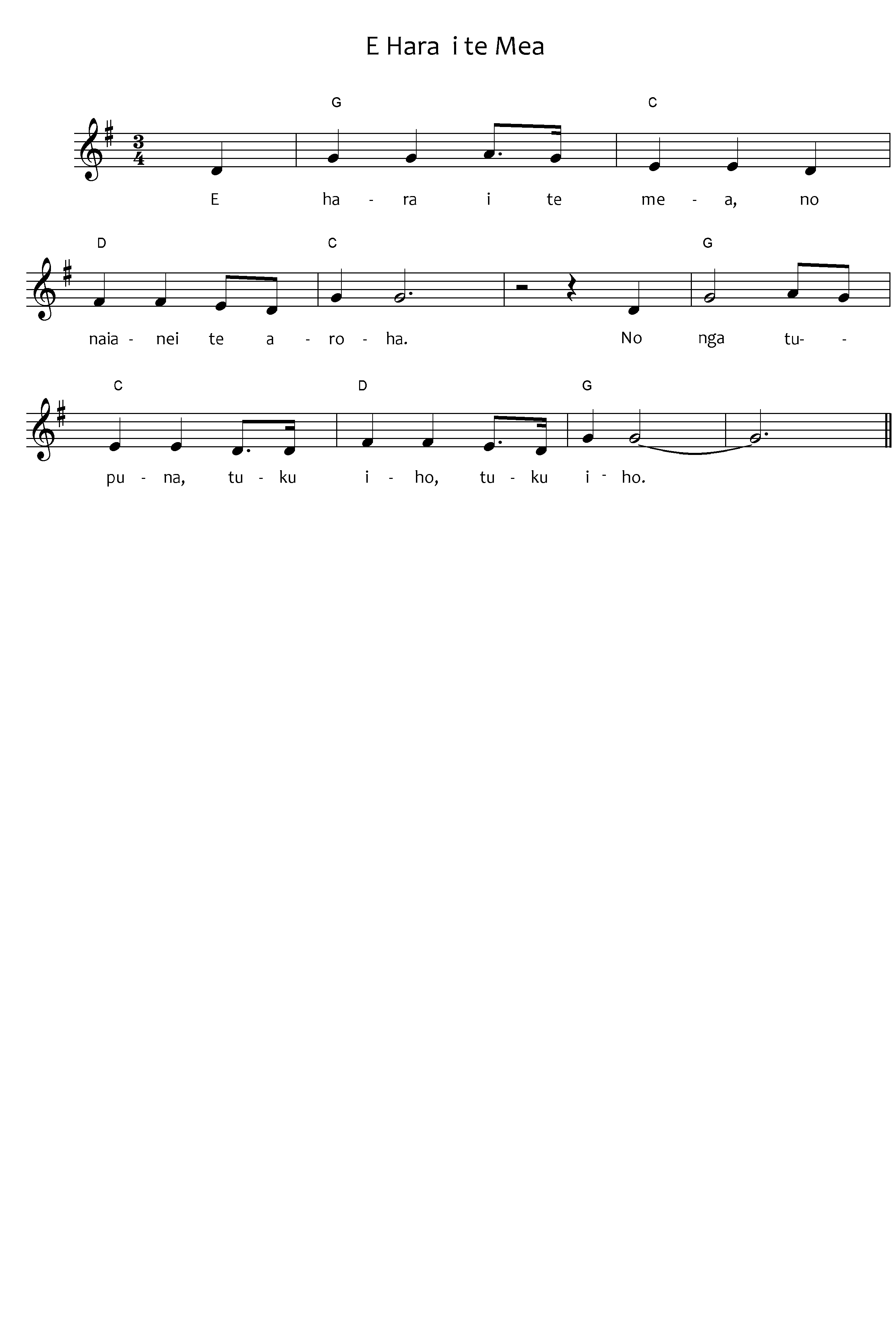

Not the thing  
of recent times, is love  
but by the ancestors it has been  
passed down, passed down.  
  
From the land, the land  
comes the wellbeing of the people;  
by the ancestors it has been  
passed down, passed down.  
  
Faith, hope  
and love;  
by the ancestors they have been  
passed down, passed down.

Eharai te mea**1**  
Nō nāianei te aroha  
Nō ngā tūpuna  
Tuku iho, tuku iho  
  
Te whenua, te whenua  
Te oranga o te iwi  
Nō ngā tūpuna  
Tuku iho, tuku iho  
  
Whakapono, tūmanako  
Te aroha te aroha;  
Nō ngā tūpuna  
Tuku iho, tuku iho.

**Notes**

*1 – alternative verse 3 below*

Whakapono, tūmanako

Ko te mea nui ko te aroha

Nō te Atua

Tku iho, tuku iho

*2 – tuku iho*

Sometimes *tuku iho* may be sung as *i tuku iho*

***Please note:*** the tohutō (macrons) are important, as they indicate correct pronunciation. Please ensure when you copy words that the tohutō are in place as indicated by the text written below the music on this page. The music writing program used for the sheet music does not allow the inclusion of tohutō.

The translation is not intended to be sung.

When singing Waiata in your parish / faith community, please always include the translation so people can know what they are singing.

### *E Hara I te Mea, composer Eru Timoko Ihaka, Public Domain,*

### *See New Zealand Folk Song Website*