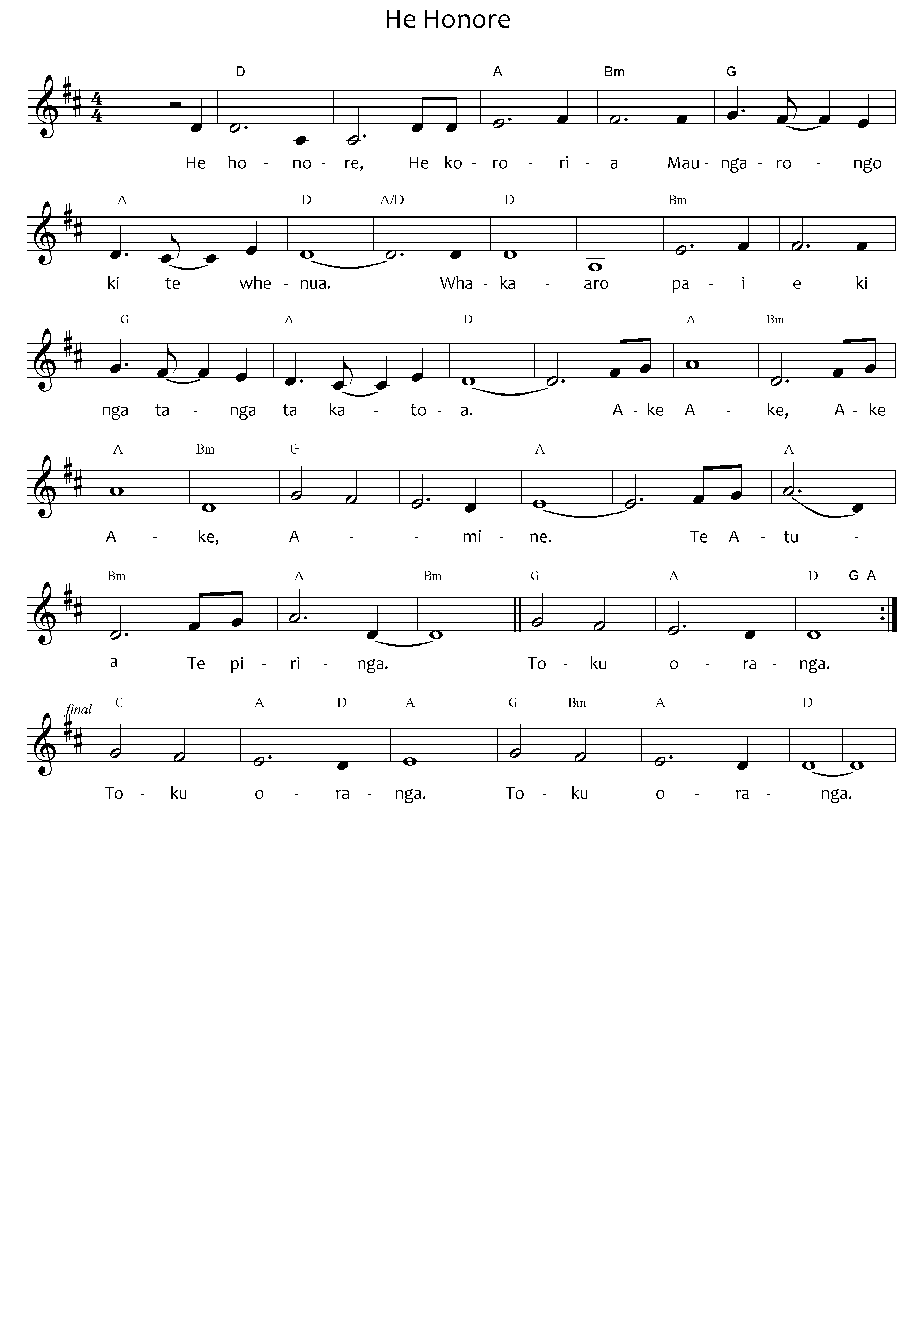
He hōnore, he korōria
Maungārongo ki te whenua
Whakaaro pai e
Ki ngā tangata katoa
Ake ake, ake ake
Āmene
Te Atua, te piringa,
Toku oranga
Honour, glory and
peace to the land
May goodwill come
to all people,
for ever and ever,﻿
for ever and ever.
Amen.
The Lord is my refuge
and my life.
Please note: the tohutō (macrons) are important, as they indicate correct pronunciation. Please ensure when you copy words that the tohutō are in place as indicated by the text written below the music on this page. The music writing program used for the sheet music does not allow the inclusion of tohutō.
The translation is not intended to be sung.
When singing Waiata in your parish / faith community, please always include the translation so people can know what they are singing.
He Hōnore – words of Biblical and Tūhoe origin.
Composer Ranui Ngarimu and Taina Piripi Ngarimu
Public Domain

