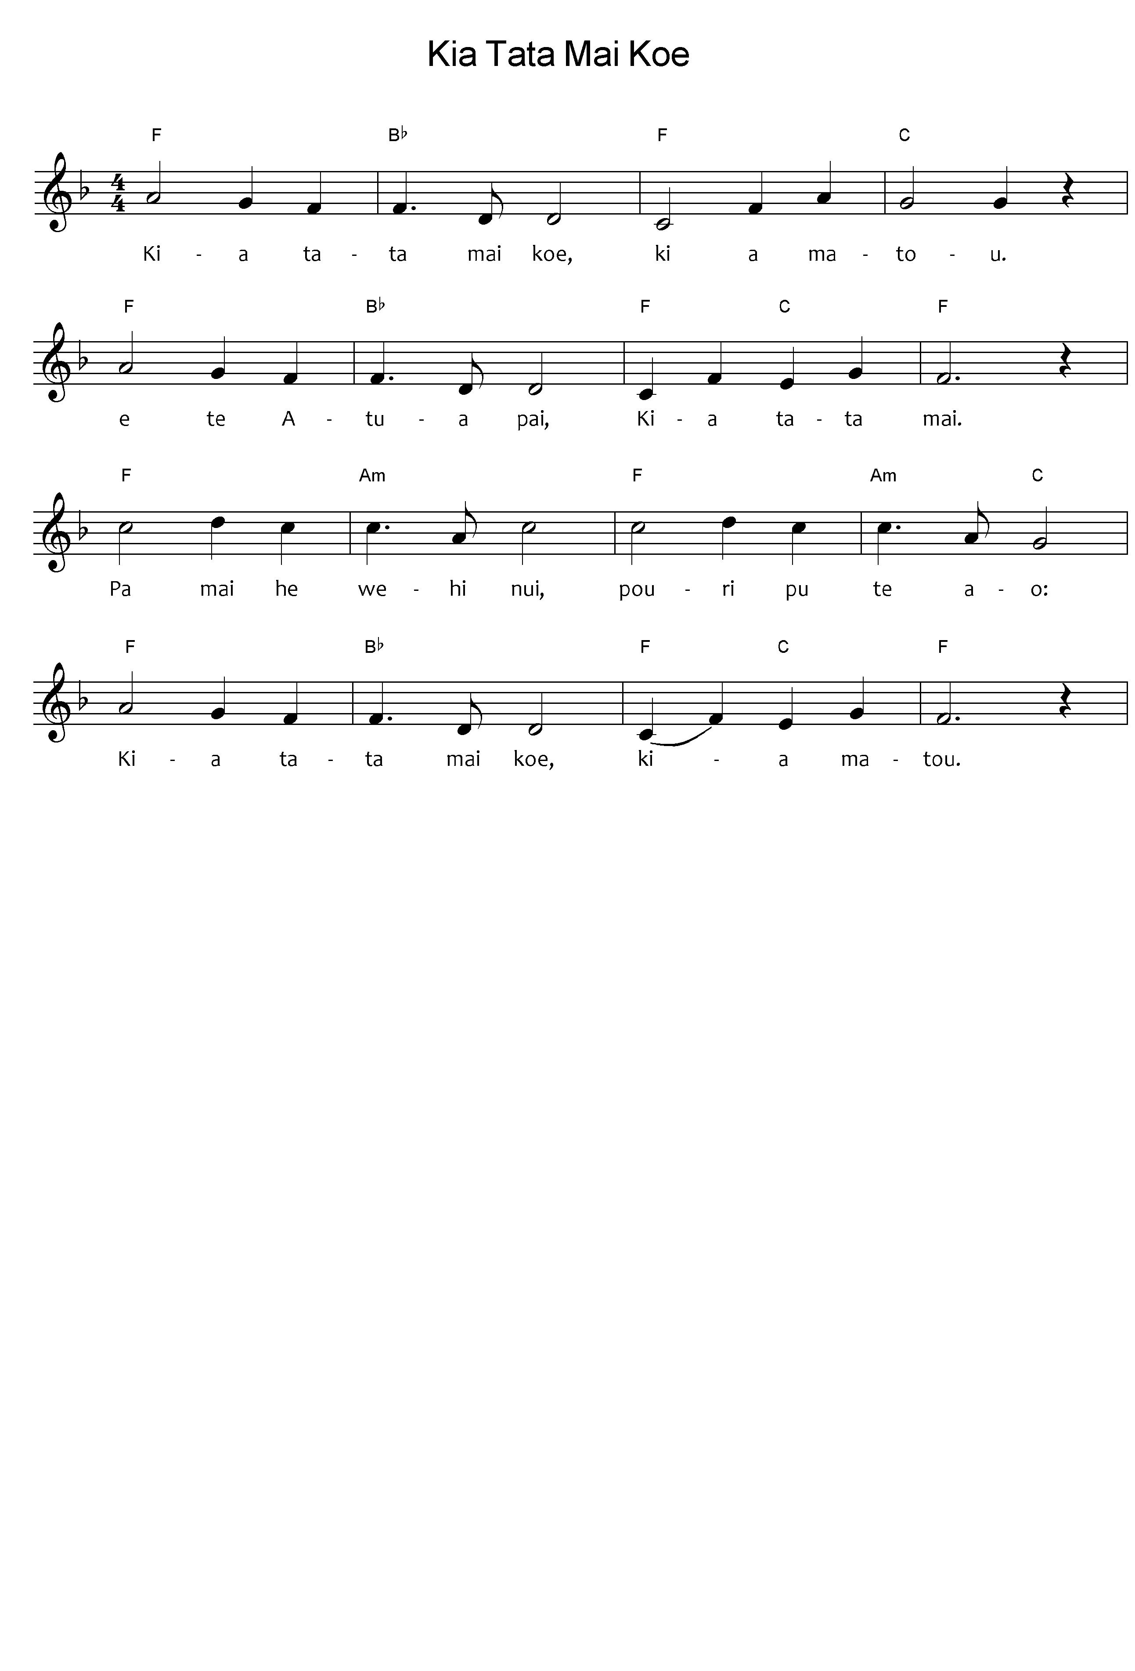

Kia tata mai koe, ki a matou

E te Atua pai, kia tata mai.

Pa mai he wehi nui, pouri pu te ao:

Kia tata mai koe, kia matou.

Maringa noa he wai, ngā kamo nei,

Te kitea atu koe, Tā matou e whai nei.

Matou arohatia , e noho pani nei

Kia tata mai koe, kia matou.

***Please note:*** the tohutō (macrons) are important, as they indicate correct pronunciation. Please ensure when you copy words that the tohutō are in place as indicated by the text written below the music on this page. The music writing program used for the sheet music does not allow the inclusion of tohutō.

The translation is not intended to be sung.

When singing Waiata in your parish / faith community, please always include the translation so people can know what they are singing.

Be very close to us O God

Good Lord

Fear and darkness have come upon the world

Draw near to us

We drink only drink the living water

We see you, we are with you,

Comfort us who mourn

Stay near to us

*Kia Tata Mai koe – composer; words unknown, tune; Nearer My God to Thee - Lowell Mason*

*Public Domain, sing Praise 209, Ngā Hīmene 231*