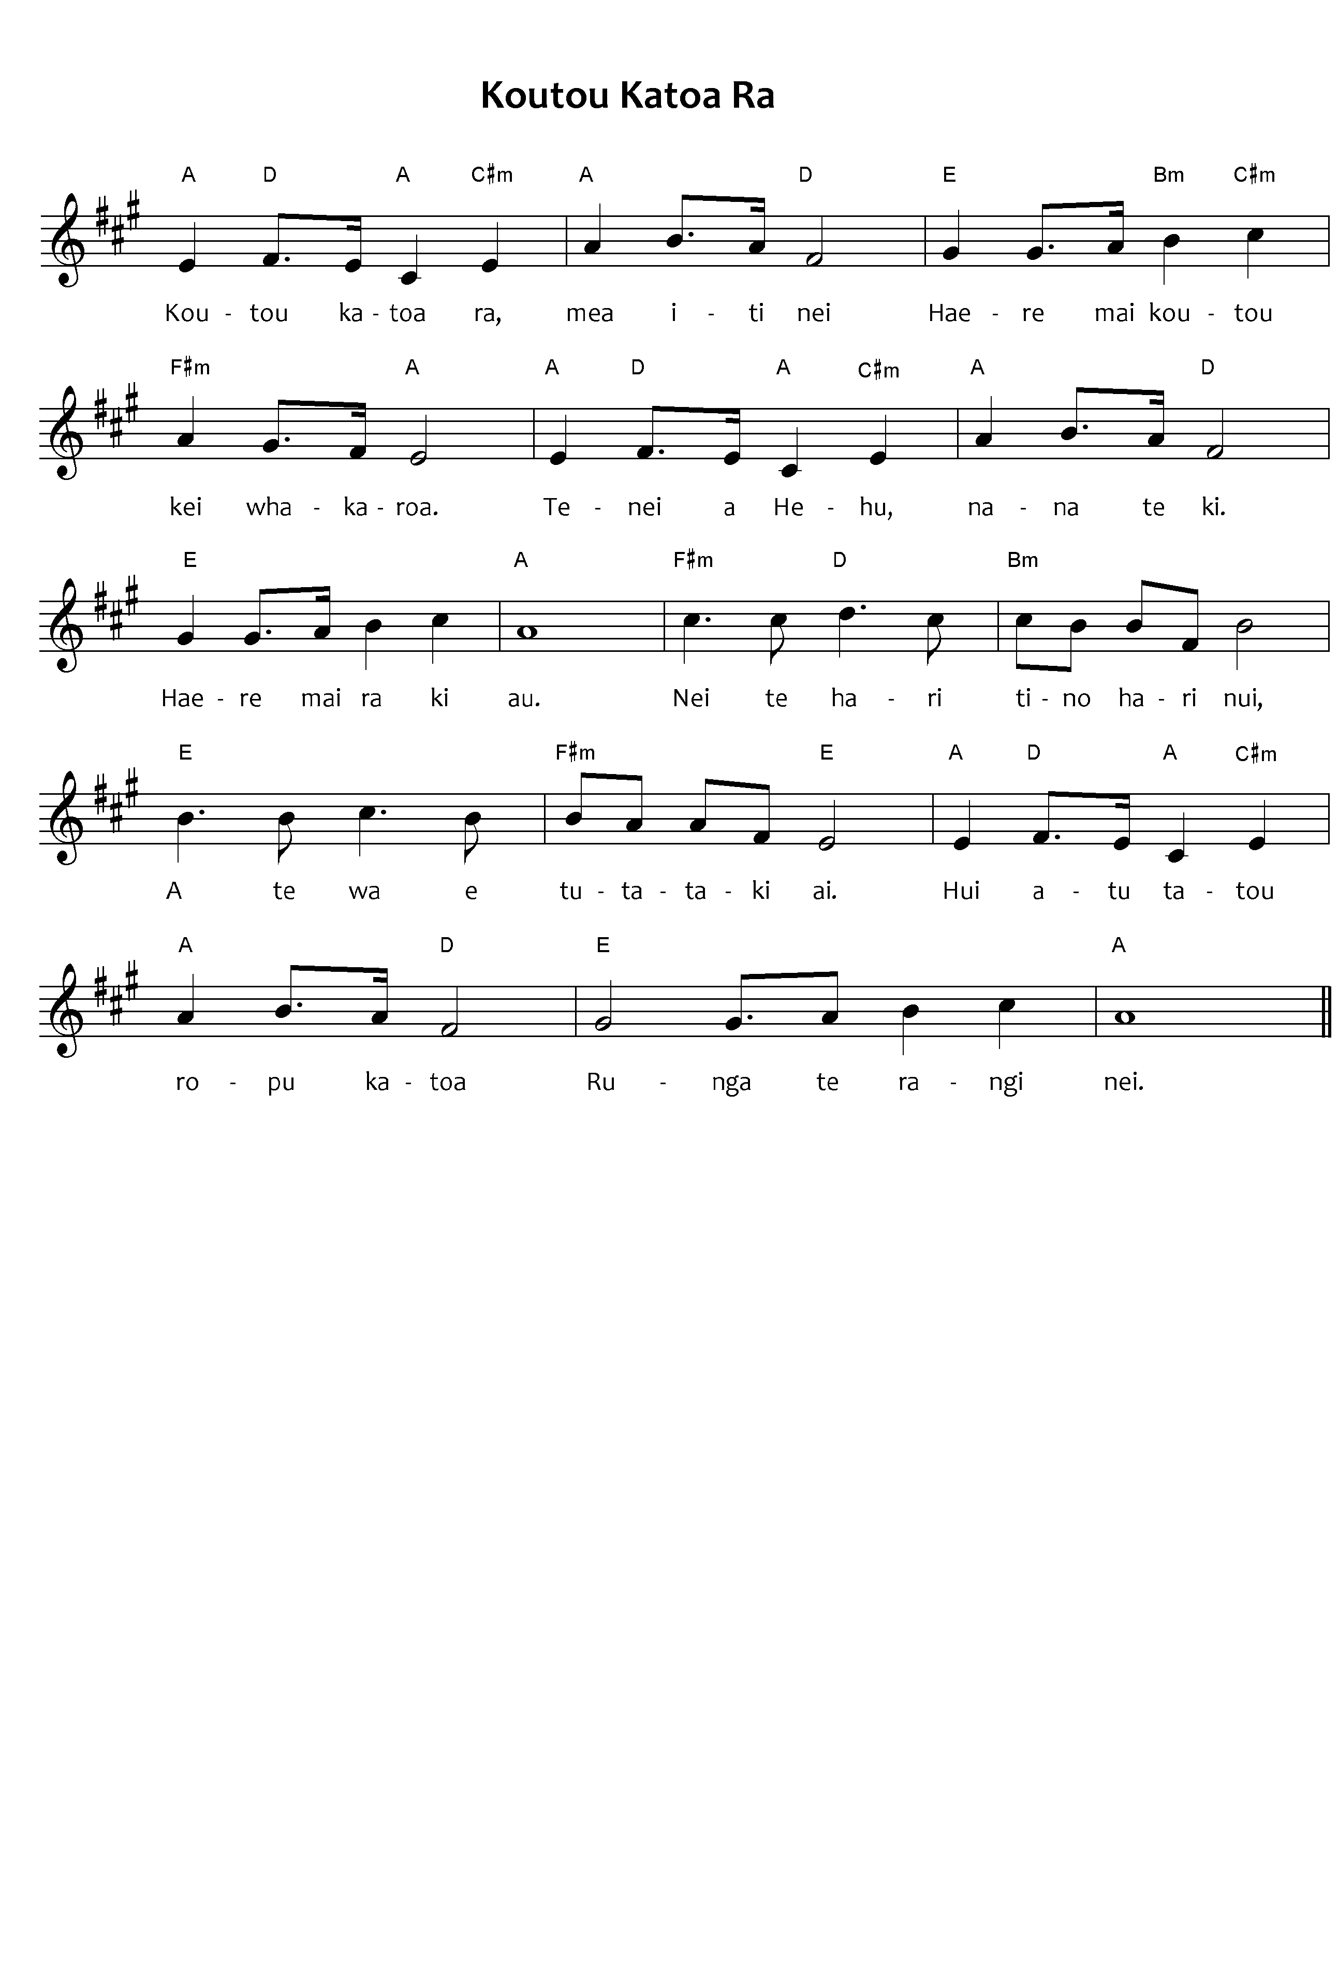

***Please note:*** the tohutō (macrons) are important, as they indicate correct pronunciation. Please ensure when you copy words that the tohutō are in place as indicated by the text written below the music on this page. The music writing program used for the sheet music does not allow the inclusion of tohutō.

The translation is not intended to be sung.

When singing Waiata in your parish / faith community, please always include the translation so people can know what they are singing.

All of you, also the little ones  
Come all of you, do not tarry  
This is Jesus who said  
"Come to Me."  
  
 *Chorus*

Here is the joy, the great joy  
At the time when we shall meet.  
Let us gather into a group  
For this coming day.

"Allow them in" was His message  
"I accept all, let no one be held back  
Assemble you all, turn your faces here  
Come to Me."  
  
Here are the thoughts, for all time  
For He says to accept (everyone)  
'Twas He who asked, 'twas He who said  
"Come to Me."

Koutou katoa rā mea iti nei  
Haere mai katou kei whakaroa  
Tēnei a Hēhu Nāna te kï  
Haere mai rā ki a Au.

*Chorus*  
Nei te hari tino hari nui  
A te wā e tutataki ai  
Hui atu tātou rōpū katoa  
Runga i te te rangi nei.

"Tukua mai rātou" nei Tana kī  
Aku i pai ai, kei puritia  
Mine mai katou, anga mai nei  
"Haere mai rā ki a Au."  
  
Nei rā whakaaro tūturutia  
Tāna e ki nei me whakaae  
Nāna te tono, Nāna te kī  
Haere mai rā ki a Au.

*Koutou Katoa Rā – This is the Māori version of a hymn composed by G F Root.*

*Ngā Hīmene222, Public Domain*