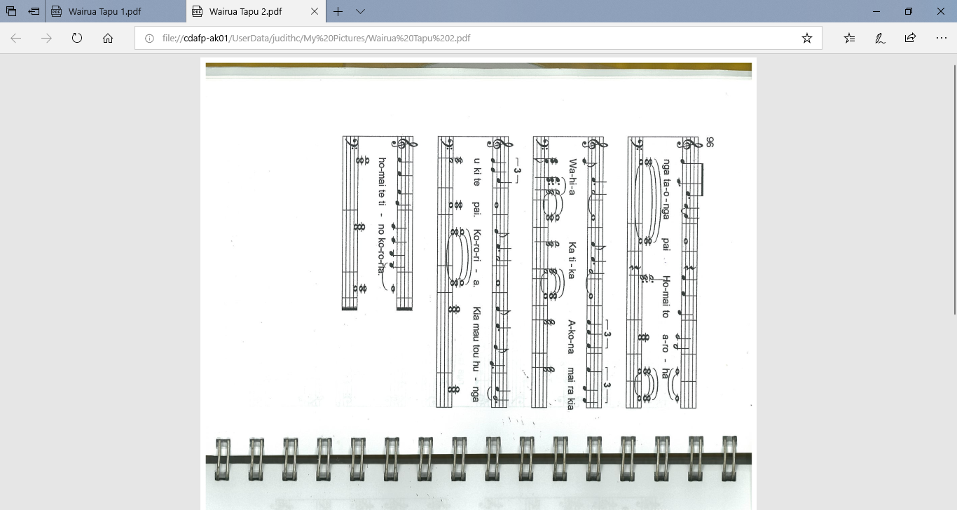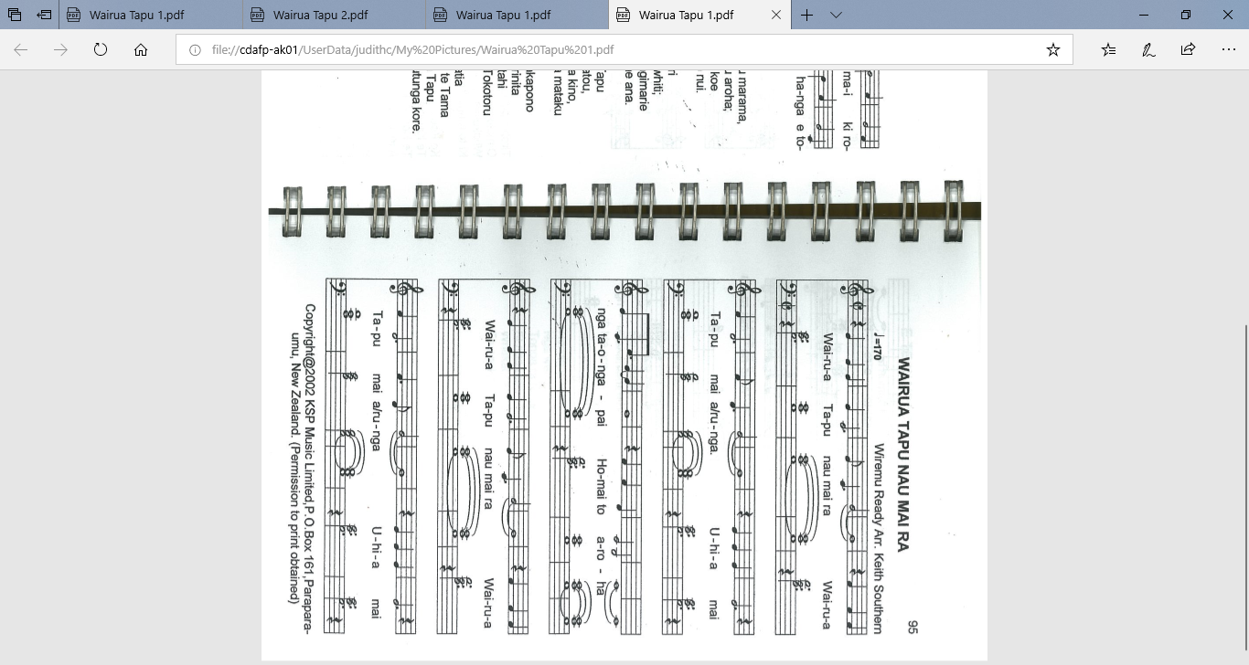

*Wairau Tapu by Wiremu Ready, arr. Keith Southern.*

*Printed in Ngā Hīmene – complied by W Tuerlings 2004*