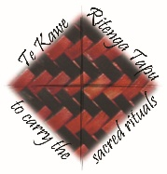
Tekau mā toru o Mahuru - September 13th
Liturgy Centre
Catholic Diocese of Auckland
Liturgy of the Word
Lectio Divina – Holy Listening
Lectio Divina, or Holy Listening is promoted as a way of hearing God’s Word. It is listening with the heart.
1. Listen attentively as the Word is read, or as you read it.
2. Notice any word or phrase that seems to stand out or makes you think or feel something. Hold on to it mentally.
3. When the reading is finished, repeat that word of phrase in your mind, almost as if you are taking it for a walk.
4. When that time of prayer is ended, just let the words go.
In this prayer, we come to meet our God who walks with us. When we encounter the Word of God, we are changed..
Spend a little time in Lectio Divina – Holy Listening at the end of the readings.

SONG: Mother Earth https://www.youtube.com/watch?v=LKBRledO_wk&feature=youtu.be

SIGN OF THE CROSS: In name of the Father… OR Ki te ingoa…Tēnā Koutou Katoa – Welcome. Today is the 24th Sunday of Ordinary Time and this week is te wiki o te reo Māori – Māori language week. We are called together now in a spirit of mercy and forgiveness – atawhai me murua. In this Laudato Si Anniversary Year, Pope Francis is asking families to embark on a 7-year journey toward integral ecology. Let us take a few moments to think about that and be mindful that are one body - Christ’s body.
READER: Wherever 2 or 3 are gathered, Christ is present. Let us pause a moment to be aware of Christ’s presence with us now.
You have made us to live our lives on earth, sensitive to landscape and environment, Lord have mercy (All) Lord have mercy
You have made us to live in communities and towns where our lives are interconnected, Christ have mercy (All)Christ have mercy
You have made us people who are dependent on each other and the natural world for our livelihood, Lord have mercy, (All) Lord have mercy

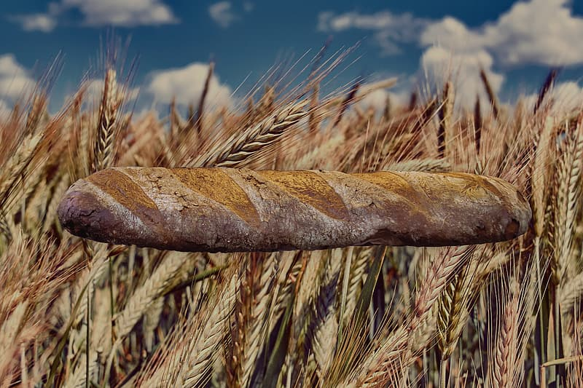
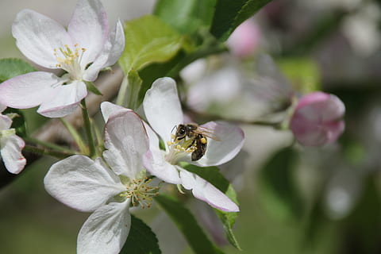
READER: Look at the pictures for a few moments.
‘Teach us to discover the worth of each thing, to be filled with awe and contemplation, to recognize that we are profoundly united with every creature.’ A Prayer for our Earth

DISCUSS: How can we help our children become more conscious that ‘we are profoundly united with every creature?’

A Song – Te Aroha https://www.youtube.com/watch?v=uefJdSCkzPo

COLLECT/OPENING PRAYER: Thank you for your thoughts. Let’s take a few moments now to bring to mind our personal intentions. (Allow silence - 1 minute)
Look upon us O God, Creator and ruler of all things, and, that we may feel the working of your mercy, grant that we may serve you with all our heart. Through our Lord Jesus Christ, your Son, who lives and reigns with you in the unity of the Holy Spirit, one God, forever and ever.
All: Amen.

FIRST READING: Sirach 27:30 -28:7
Anger and wrath, these also are abominations,
yet a sinner holds on to them.
The vengeful will face the Lord’s vengeance,
for he keeps a strict account of their sins.
Forgive your neighbour the wrong he has done,
and then your sins will be pardoned when you pray.
Does anyone harbour anger against another,
and expect healing from the Lord?
If one has no mercy toward another like himself,
can he then seek pardon for his own sins?
If a mere mortal harbours wrath,
who will make an atoning sacrifice for his sins?
Remember the end of your life, and set enmity aside;
remember corruption and death, and be true to the commandments.
Remember the commandments, and do not be angry with your neighbour;
remember the covenant of the Most High, and overlook faults.
The Word of the Lord – Ko te kupu a te Ariki
ALL: Thanks be to God - Whakamoemiti ki te Atua
Silence: Consider: When, where, how does my mercy towards another become visible?

PSALM: 103 – The Lord is kind and merciful, the lord is kind and merciful. Slow to anger rich in kindness. The Lord is kind and merciful. https://www.youtube.com/watch?v=855D-RkS4WQ

SECOND READING: Romans 14:7-9
Brothers and sisters:
None of us lives for oneself, and no one dies for oneself.
For if we live, we live for the Lord,
and if we die, we die for the Lord;
so then, whether we live or die, we are the Lord’s.
For this is why Christ died and came to life,
that he might be Lord of both the dead and the living
The Word of the Lord – Ko te kupu a te Ariki
ALL: Thanks be to God – Whakamoemiti ki te Atua
Silence: “None of us lives for oneself.’ Where do I see this?

GOSPEL: Matthew 18:21-35
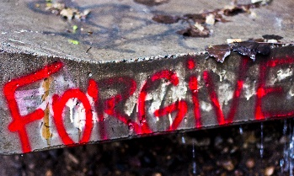
Peter approached Jesus and asked him,
“Lord, if my brother sins against me,
how often must I forgive?
As many as seven times?”
Jesus answered, “I say to you, not seven times but seventy-seven times.
That is why the kingdom of heaven may be likened to a king
who decided to settle accounts with his servants.
When he began the accounting,
a debtor was brought before him who owed him a huge amount.
Since he had no way of paying it back,
his master ordered him to be sold,
along with his wife, his children, and all his property,
in payment of the debt.
At that, the servant fell down, did him homage, and said,
‘Be patient with me, and I will pay you back in full.’
Moved with compassion the master of that servant
let him go and forgave him the loan.
When that servant had left, he found one of his fellow servants
who owed him a much smaller amount.
He seized him and started to choke him, demanding,
‘Pay back what you owe.’
Falling to his knees, his fellow servant begged him,
‘Be patient with me, and I will pay you back.’
But he refused.
Instead, he had the fellow servant put in prison
until he paid back the debt.
Now when his fellow servants saw what had happened,
they were deeply disturbed, and went to their master
and reported the whole affair.
His master summoned him and said to him, ‘You wicked servant!
I forgave you your entire debt because you begged me to.
Should you not have had pity on your fellow servant,
as I had pity on you?’
Then in anger his master handed him over to the torturers
until he should pay back the whole debt.
So will my heavenly Father do to you,
unless each of you forgives your brother from your heart.”
The Gospel of the Lord - Ko te rongopai a te Ariki
ALL: Praise to you Lord Jesus Christ - Kia whakanuia rā koe e Hēhu Karaiti.

SILENT REFLECTION: Recall a few words from the readings that seemed to stand out as you read or listened. Sit quietly and let these words go over and over in your mind – Lectio Divina. (3 minutes)

READER: The two readings below both come from the Papal Document Laudato Si. Read both then discuss.
‘This sister now cries out to us because of the harm we have inflicted on her by our irresponsible use and abuse of the goods with which God has endowed her. We have come to see ourselves as her lords and masters, entitled to plunder her at will. The violence present in our hearts, wounded by sin, is also reflected in the symptoms of sickness evident in the soil, in the water, in the air and in all forms of life. Laudato Si #2
Question: What are the ‘symptoms of sickness evident in the soil and water’?

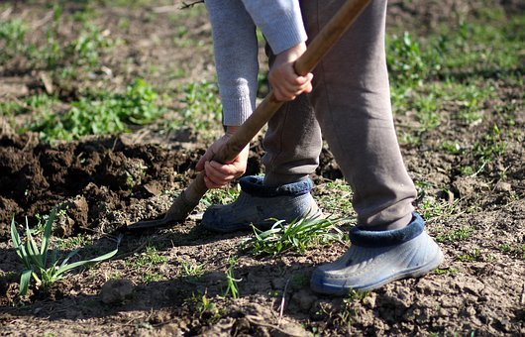
READER: When we speak of the “environment”, what we really mean is a relationship existing between nature and the society which lives in it. Nature cannot be regarded as something separate from ourselves or as a mere setting in which we live. We are part of nature, included in it and thus in constant interaction with it. Laudato Si #139
Question What could help us become more aware that we are ‘part of nature, included in it and thus in constant interaction with it?’
DISCUSS: What responses do we have to these passages from Laudato Si, the questions or the images?

A Prayer for our Earth and Examen https://www.youtube.com/watch?v=u7XfedvZ4DI

Prayer of the Faithful – we pray for the needs of the Church and the world.
For the Church – that it be a house of mercy reaching out to the world with arms of comfort and healing.
(Silence) Reader: E te Ariki All: Whakarongo mai rā ki a mātou.

For world leaders – that they focus their power and energy on creating pathways of peace rather than seeking retribution for wrongs done in the past.
(Silence) Reader: E te Ariki All: Whakarongo mai rā ki a mātou.

For an end to the Covid-19 pandemic – that there will be effective healthcare services for refugees and people living in poverty and that a vaccine will be found and made available to them.
(Silence) Reader: E te Ariki All: Whakarongo mai rā ki a mātou.

For Aotearoa New Zealand in this election year – that our politicians encourage just business practices and promote social structures which support all people, including our most vulnerable citizens.
(Silence) Reader: E te Ariki All: Whakarongo mai rā ki a mātou.

For an integral ecology – that as families we discuss and recognise the effect our way of living has on our planet, and that as families we talk about how we might understand and support the wellbeing and interconnectedness of all life.
(Silence) Reader: E te Ariki All: Whakarongo mai rā ki a mātou.

For the each of us gathered here – that we forgive those who have hurt us, show mercy to those who have wronged us, refrain from harsh judgements about other people and use our energy to build relationships of love and mercy.
(Silence) Reader: E te Ariki All: Whakarongo mai rā ki a mātou.
Confirm, O God, in unity and truth the Church you gather in Christ. Encourage the fervent, enlighten the doubtful, and bring back the wayward. Bind us together in mutual love, that our prayer in Christ’s name may be pleasing to you. Grant this through our Lord Jesus Christ, your Son, who lives and reigns with you in the unity of the Holy Spirit, God for ever and ever… Amen

READER: Let’s pray together, this prayer from ‘A Christian Prayer in Union with Creation - Laudato Si and then pray the Lord’s Prayer.
Triune Lord, wondrous community of infinite love,
teach us to contemplate you
in the beauty of the universe,
for all things speak of you.
Awaken our praise and thankfulness
for every being that you have made.
Give us the grace to feel profoundly joined
to everything that is.
Our Father who art ….

COLLECTION: Part of our commitment as Christian is to give to those in need.
Discuss - who or what is in need of our mercy.

Thank you for your kindness. Thank you for your participation. Let us go in peace to love and serve God. Kia tau te rangimārie ki a koutou – Peace be with you.
All: Thanks be to God.

SONG: E te Ariki https://www.youtube.com/watch?v=4tyMVnO_N3Y
……………………………………………………………………………………………………………………………………………..
Resource: A Prayer for our earth - https://www.youtube.com/watch?v=3fKcudwt-Nk

