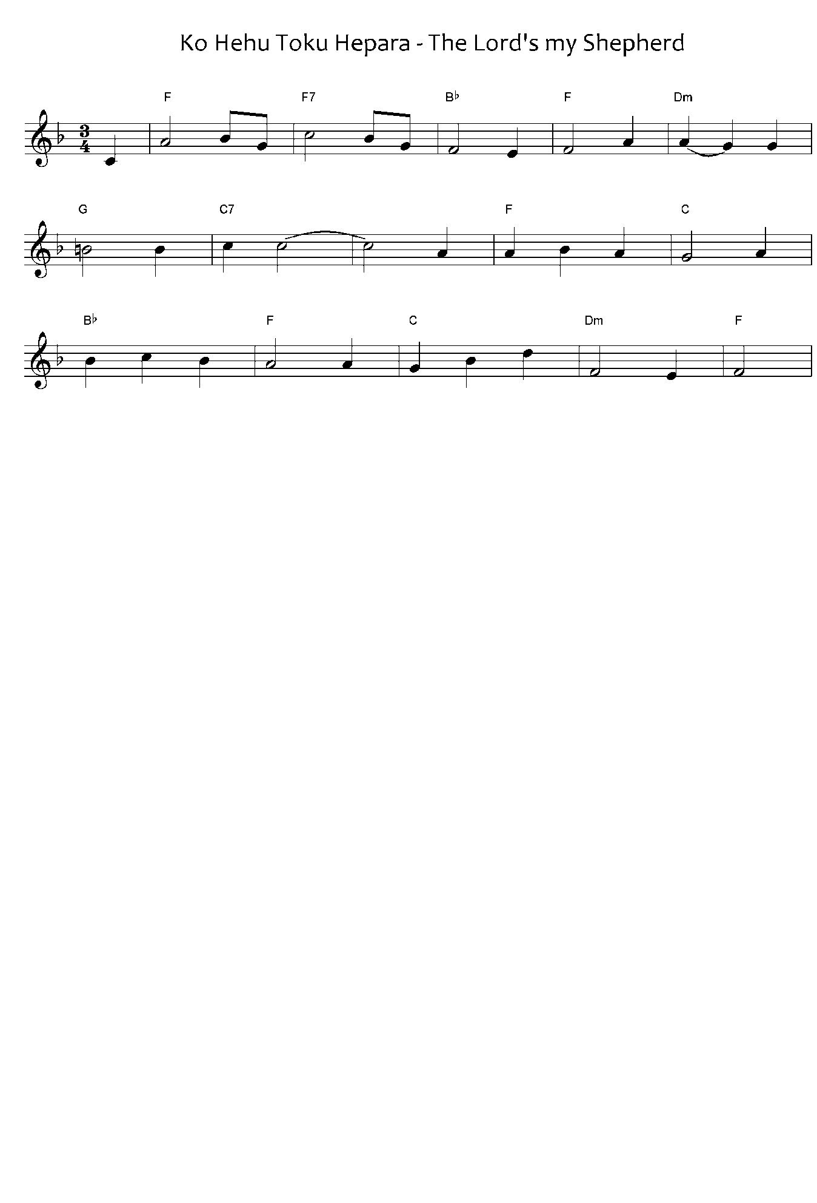

Jesus is my shepherd

He guards me faithfully

He is kind

And compassionate to me.

He leads me

By the rivers

That I may drink from

The source of life

Even in the wastelands

Where I will be

All will be good

Here is my salvation

I know

He still loves me

I will seek and draw near

Into the flock

His kindness endures

It will never end

He leads me

Through all life.

Ko Hehu tōku Hēpara

He kaitiaki pono

Ko tana atawhai kia au

He mahi tohu tonu

E arahina au e ia

Te taha o nga awa

Kia inu iho ai ahau

Te puna o te ora

Ngā wahi mato mato nui

E tae ahau ki rera

Ko ana kai papai katoa

Hei ora enei moku

Kuware au kotiti ke

Aroha tonu mai ia

E rapua au e kumea mai

Ki roto ki te kahui

E pumau tona atawhai

E kore ra e mutu

E arahina au e ia

Tae atu ki te ora.

***Please note:*** the tohutō (macrons) are important, as they indicate correct pronunciation. Please ensure when you copy words that the tohutō are in place as indicated by the text written below the music on this page. The music writing program used for the sheet music does not allow the inclusion of tohutō.

The translation is not intended to be sung.

When singing Waiata in your parish / faith community, please always include the translation so people can know what they are singing.

*He Tōku Hēpara - composer (words) unknown. Tune, Crimond (The Lord’s My shepherd) – J S Irvine.*

*Public Domain, Sing Praise 57, Ngā Hīmene 77*