16.2.21 Oral SUBMISSION to Governance and Administration Select Committee on Data & Statistics Bill 2021

I’m Peter Garrick and I speak on behalf of the Social Hazards Committee of the Justice and Peace Commission of the Catholic Diocese of Auckland.

Our submission is based on the recognition of the human dignity and right to protection and support of all members of society particularly the most vulnerable.

We welcome the introduction of the Data & Statistics Bill 2021 particularly its emphasis on incorporating the partnership of Tiriti o Waitangi.

We wish to comment on the first aim of the Data and Statistics Bill to
- ‘recognise the Crown's responsibility to consider and provide for Māori interests in data and statistics’

We believe this aim has profound consequences for the integrity of the data used to allocate substantive Government funds underpinning the fifth aim of the Bill to
- ‘continue to provide appropriate safeguards and protections to ensure public trust and confidence in the collection and use of data for official statistics and research.’

This Bill is particularly timely given that the 6 March 2018 Census completion rate was ‘lower than expected’ requiring Statistics NZ to use less accurate statistical estimates, so called ‘administrative data’, rather than actual census data to make up for the 10% loss they claimed at the time.

In fact as reported by the March 2019 Independent Review the situation was much worse than that as the census attracted only an 83% response rate well short of the 94% census percent target and a nine percent drop from the previous 2013 New Zealand census, the worst for over 50 years.

Even more disturbing the response rate for Māori was 68% and Pasifika 65% indicating that a third of these communities were actually not counted at all! This is a dramatic decrease from the 2006 Census which had an overall response nationally of 94 percent, Māori 93 percent and Pasifika 92 percent.

Over little more than a decade structured inequality has been created so that up to a third of Maori and Pasifika communities are deemed not to be worth counting.

Census Statistics are used to allocate Health, Social Welfare, Transport and other Government funding for each area for the following five years.

The deficiencies in the 2018 census meant that those community areas where there is a concentration of Māori or Pasifika were likely to receive substantially less funding than they would otherwise have received had the resources been put in to ensure they were actually counted.

So instead of being a tool for reducing inequality, deprivation and poverty, the deficiencies of the 2018 Census became a weapon to actually increase it.

This is a travesty in a society that values fairness and protection of the most vulnerable.

The reasons for the under-count in the 2018 Census are well documented and clearly related to offsetting IT costs by drastically reducing funding for census field officers to follow-up on households who had not filled their forms online or in paper form.
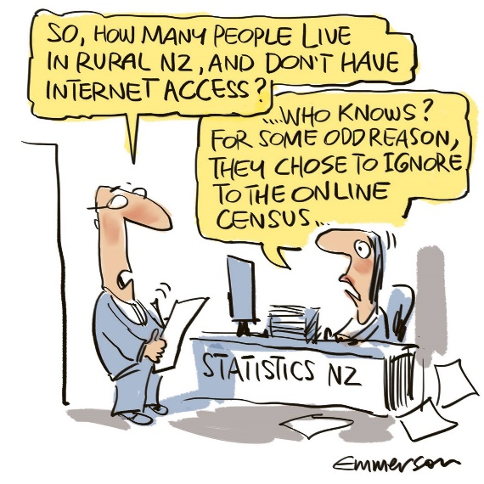
As the March 2019 Independent Review clearly and chillingly states:
‘The additional costs of developing the necessary IT systems were largely offset by a reduced field workforce.’

The end result was that vulnerable communities with traditionally low response rates were further disadvantaged. And with the overall count rate down to 83% who else is missing out? We don’t know what we don’t know. As Emmerson’s cartoon points out so well:

It is commendable that in Clause 14 of this Bill Māori are consulted in terms of the type of questions asked and the general conduct of the Census.

What we would like to see is a legal requirement for Government to provide the resources needed to ensure that Māori and others are not disadvantaged by being undercounted in the five-yearly census.

The recent ruling of the Waitangi Tribunal on the inequity to Māori of the one-size-fits-all approach to the Covid 19 vaccination roll-out is an example of how such inequity can occur.
Only belatedly did the Government attempt to rectify the situation.

Unfortunately even such belated efforts are not evident in the Census-gathering area.

Instead of increasing the number of enumerators (Census follow-up officers) employed to bridge the gap between the overall response rate and those for Maori and Pakifica in the 2013 census, they were slashed by 75% in the 2018 census resulting in 5200 fewer enumerators being employed, a clear case of structured social injustice.

When 2018 IT development costs are removed, it is clear that funding for the execution of the 2018 Census was substantially less than for the 2013 Census.

And who paid the price for such dereliction of duty for the common good? None other than those who can afford it least with up to a third Māori and Pacifica communities not counted at all and so largely unfunded for Health, Social Welfare, Education, Transport and other Government funding for their area for the following five years.

75% of health funding for example is determined by Census figures. Child Poverty Action Group co-convenor Alan Johnson said
"What you will get in places like South Auckland is there might be 10,000 - 15,000 people missing from the count - well the DHB won't be getting funded for them so them and everyone else in that area will struggle with less funding."

This had a particularly significant effect in the Auckland area resulting in the increased deprivation particularly for Māori and Pasifika communities.

As Bryce Edwards commented in the NZ Herald on 6 March 2019:
"Newtly released information shows Stats NZ employed 1800 enumerators, or field staff, to knock on doors and uncover those who failed to complete the Census 2018. This was a substantial drop from the 7000 boots on the ground during Census 2013".

And the plot thickens. By choosing the fourth least preferred option of the paper of Census funding models presented to cabinet in December 2019 and incorporated in the May 2020 Budget, the funding provided for the 2023 Census is below equivalent levels for the 2013 and earlier censuses.

The Government of the day was officially warned that the likely result of choosing this option would be that ‘relatively minor implementation issues could cause response rates for some hard to count groups (including Maori and Pasifica) to fall to unacceptably low levels.’

Such decisions undermine the provisions in clause 14 of this Bill which needs to be amended to render such deliberate underfunding illegal.

Clause 84 of the Bill says
‘It is an offence to interfere with, hinder or obstruct the Statistician … in the exercise of any power conferred by this Bill.’ And Clause 9 states ‘This Act bounds the Crown’.

This is not a light matter but in fact has substantive economic consequences in terms of the allocation of Government funds particularly to vulnerable communities.

As the official introduction to the 2023 Census indicates
‘Some types of information gathered by the census is the highest quality information we hold as a nation… and informs how billions of dollars are spent across the country and in our communities to make a difference to everyone’s future.’

We would also like to see Clause 35 strengthened to include a wider community consultation on questions to include in the Census.

This Bill with amendments as suggested is a good opportunity to enable this to happen equitably by insisting that proper resources are allocated to ensure the 2023 and subsequent censuses provide accurate and reliable data to deliver billions of dollars equitably so as to make a difference to everyone’s future.

I wish to thank Select Committee members for the opportunity to speak on this matter that strikes at the heart of what it means to become a fair and equitable society.

For the convenience of Committee members I’ll email through what I’ve said today together with the appropriate references.

I’m happy to answer any questions.

Contact information
Name | Peter Garrick, Executive Secretary
Organisation | Social Hazards Committee, Justice & Peace Commission, Catholic Diocese of Auckland
Address | 30 New St Private Bag 47904, Ponsonby, Auckland 1144
Email | peterg@cda.org.nz

Independent Review March 2019 https://www.stats.govt.nz/assets/Uploads/Report-of-the-Independent-Review-of-New-Zealands-2018-Census/independent-review-report.pdf
2013 Census figures were 92 percent nationally, 88 percent Māori and Pasifika, Asian 91 percent.
Bryce Edwards NZ Herald 6 March 2019 https://www.nzherald.co.nz/nz/political-roundup-the-absolute-debacle-of-the-2018-census/2ERWBW5ZOWR45OFM3Z56L4WMX4/
Independent Review March 2019 op cit p.70
NZ Herald 21 December 2021 https://www.nzherald.co.nz/nz/covid-19-delta-outbreak-waitangi-tribunal-says-crown-actively-breaching-treaty-in-covid-response-for-maori/3XRKZ2OT4KYBKMOQX32CLSOOX4/
As quoted in Cate Broughton 5 March 2019 https://www.stuff.co.nz/national/health/111036613/health-boards-schools-may-lose-funding-as-ministries-forced-to-use-2013-census-data
Bryce Edwards NZ Herald 6 March 2019 https://www.nzherald.co.nz/nz/political-roundup-the-absolute-debacle-of-the-2018-census/2ERWBW5ZOWR45OFM3Z56L4WMX4/
P.70 Department of Statistics NZ’s Census of Population & Dwellings 10 December 2019 cabinet paper
https://www.census.govt.nz/about/what-is-the-census/ December 2021

