Easter Sunday
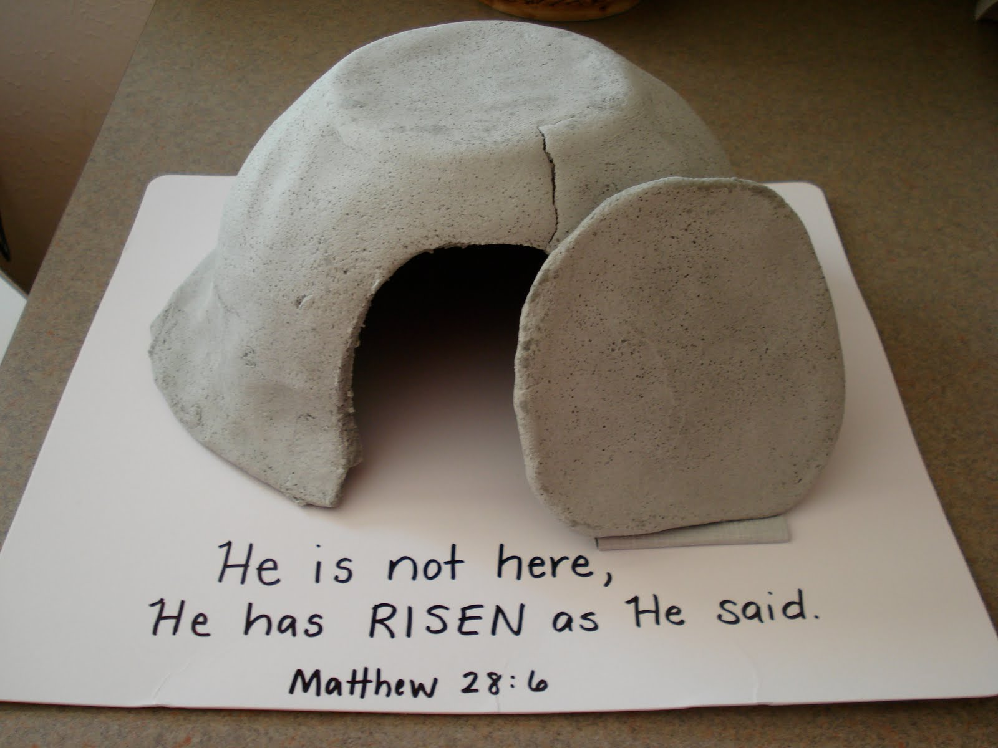
There are no resources set for Easter Sunday.
It is expected that we celebrate as a family on this Special day.
