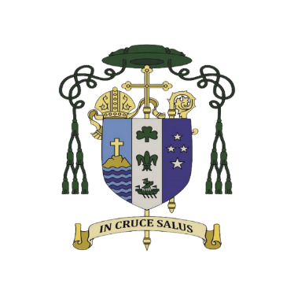
Catholic Diocese of Auckland
Liturgy Centre – Te Kawe Ritenga Tapu
Music Suggestions for 22nd February 2023
Ash Wednesday
Ash Wednesday  22nd February  Entrance Antiphon  You are merciful to all, O Lord, and despise nothing that you have made.  You overlook people’s sins, to bring them to repentance, and you spare them, for you are the Lord our God.  Communion Antiphon  Those who ponder the law of the Lord day and night will yield fruit in due season. | Joel 2:12-18  Let your hearts be broken, not your garments torn.  Psalm 51  Be merciful, O Lord, for we have sinned.  2 Corinthians 5:20 – 6:2  At the favourable time, I have listened to you; on the day of salvation, I came to your help.  Matthew 6:1-6, 16-18  Your Father who sees all that is done in secret will reward you.
Tama Ngākau Mārie SP 285 Ngā Hīmene 92, KKM
A New Heart for A New World - T Watts M O'Brien AOV 1/158 OL* 5901930f67594
Ashes - Tom C. OL 80978
Be Thou My Vision - Eleanor Hall, Mary Byrne AOV 1/9 SP 144 OL* 592e04d2a3413
Create a Clean Heart - C Consiglio S&S 2/302 OL* 86848
Create A New Heart – M Mangan OL 126413
Forty Days and Forty Nights - George Smyttan PD OL* 84245
Grant to us O Lord a Heart Renewed - Charles Wesley & Lucien Deiss SP 103 OL* 50103
Hosea - Gregory Norbet AOV 1/30 OL* 90668
Led by The Spirit – Bob Hurd G&P OCP OL*80744
Lord Who Throughout These Forty Days -Claudia F Hernaman SP 219 PD OL* 92265
Micah’s Theme - Anne Kelly GA 486 OL 56005 Hear then what your God asks of you
We Find You Lord in Others Need -Giles Ambrose STTL 123
For support, feedback, questions or to offer further suggestions, contact liturgcentre@cda.org.nz
Psalms: https://www.musicformass.co.uk/ausnz/index.html These are free to use in Church but should be acknowledged when used.

