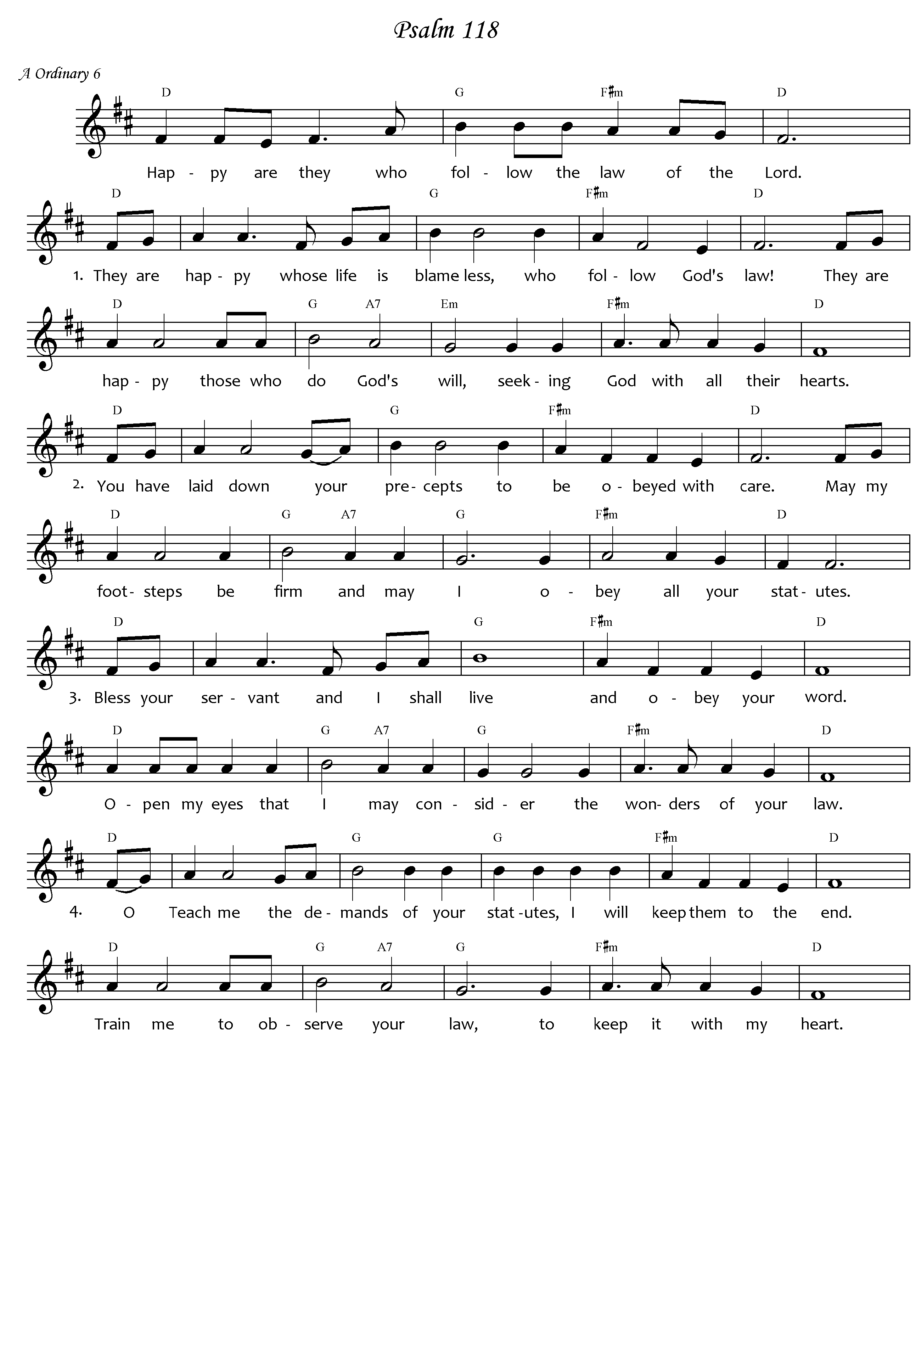

*Words based on Lectionary, RSV. Music J Courtney-Tennent © 2008. May be printed for parish use.*