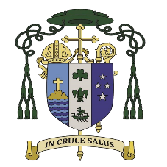 The Bishop’s Office, Mass Count returns Monday 4 December
Parish/Ethnic Community |  | Church/Centre
This is NOT your official Mass Count form but can be used to collect data for imputing into the digital form https://www.aucklandcatholic.org.nz/bishops-office-mass-counts/.
Please keep a copy for your records.
The deadline for receiving the Mass Count attendance figures is Monday 4 December.
If you have more than one location for a Mass, please indicate the appropriate Church/Centre.
Parish Roll Number, if known: _______________________________________________________
Date | Saturday Vigil Mass | Sunday am Mass | Sunday am Mass | Sunday am Mass | Sunday evening Mass | Week Total
4/5 November
11/12 November
18/19 November
25/26 November
Month Total

Date | Special Mass | Miha  Māori | Ethnic Community Mass | Ethnic Community Mass | Week Total | Special Masses are those where numbers attending are significantly different due to a celebration such as Confirmation/First Holy Communion, Parish Jubilee, Parish/ School, Youth Mass.  Please note Miha Māori and Ethnic Community Masses held in the parish separately.  Please make a note of the name of the Ethnic Community as well as the location and time of the Mass.
4/5 November
11/12 November
18/19 November
25/26 November
Month Total
If you have any queries, please email Rebecca rebeccac-n@cda.org.nz
PLEASE GO ONLINE TO COMPLETE THE MASS COUNT it requires the appropriate declaration.

