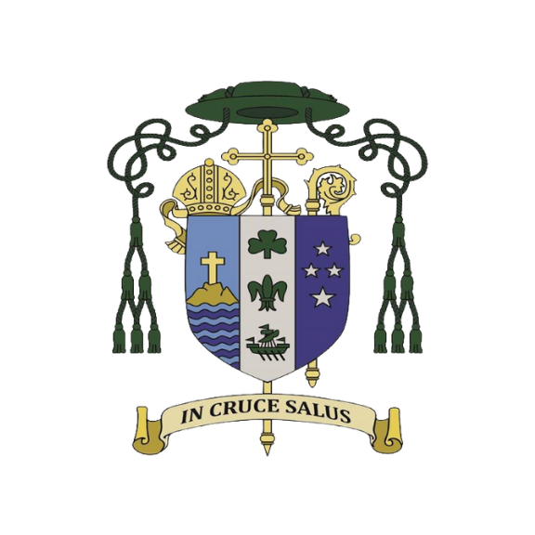
Catholic Diocese of Auckland
Parish Process for Police Vetting Under the 2026 Updated Guidance
This process is intended to guide parishes in identifying which roles may need a Police Vet, which roles may be better suited to a Ministry of Justice (MoJ) Criminal Record Check, and how to complete the full Safety Check for each person involved in ministry.

1. Considering Whether the Role Meets Police Vetting Criteria
Parishes are encouraged to assess each role individually rather than assuming it meets Police Vetting criteria. The Police Vetting Service (PVS) is applying eligibility guidelines more closely, especially in relation to vulnerable adults.

1A — Consider whether the role involves:
- Care and safety of children or young people
- Education of children or young people
- Physical care of a vulnerable adult (such as feeding, hygiene support, or administering medication)
For example:
- Altar Server Trainers
- Catechists – Sacramental Programme Coordinator/Leader
- Children’s Liturgy of the Word
- Choir Leaders – where children are included in the general choir and for children’s choir
- Crèche helpers
- Parent Helpers / Chaperons on camps
- Prison ministry teams and visitors
- Sunday School Teachers
- Youth Ministry Leaders

1B — Situations PVS does not view as meeting vetting criteria:
- Spiritual or pastoral ministry
- Transporting adults
- Emotional or mental support unless part of a professionally registered role
For example:
- Ministers of Communion to the Sick
- Pastoral Visitor
- Parish Secretary/ Operations Managers etc.
- Ministers of the Word
- Ministers of the Eucharist

2. Considering a Ministry of Justice (MoJ) Criminal Record Check
If a role does not fit Police Vetting criteria, a MoJ check may still be helpful depending on the responsibilities involved. If MOJ check is required, this will be undertaken by the parish/entity and not the Diocese.

2A-Examples include roles involving:
- Access to finances or sensitive information
- High levels of trust
- Solo work or positions of authority
- Visiting vulnerable adults at home
For example:
- Parish Secretary/ Operations Managers etc.
- Money counters.
- Ministers of Communion to the Sick.
- Pastoral Visitor.
- Finance committee members.
- Parish Pastoral Council Members.
- Board members.

3. Standard Safety Check Procedures (applies to all roles)
3A. Identity Verification
Sight original government-issued photo identification of volunteer staff in person.

3B. Referee Checks
Referee checks play an important part in the process.

For current parishioners:
- Meet with the person regarding their interest in ministry
- Speak with a non-family referee

For new parishioners:
- Meet with the person
- Contact their previous Parish Priest for relevant information
All volunteers should be paired with an experienced volunteer until safety checks are completed.

4. Preparing Police Vet Documentation (if applicable)
4A. Use accurate job titles.
4B. Provide a brief description of duties relating to vetting criteria.

5. Issuing the Safety Check Certificate
Once checks are complete, the parish may issue a Safety Check Certificate for internal use.

6. Parish Implementation Checklist
- Role assessment completed
- Identity and referee checks completed
- Police Vet or MoJ check completed if applicable
- Safety Check Certificate issued
- Documentation stored per privacy and retention guidelines

7. Additional Notes
Risk assessments, volunteer agreements, Codes of Conduct, and safeguarding training all support a strong safety checking process.

Lisa-May Gray
Safeguarding Coordinator
Catholic Diocese of Auckland

