E

Resources for
THE WEEK OF PRAYER FOR CHRISTIAN UNITY

and throughout the year

2026

"There is one body and one Spirit, just as you were called
to the one hope of your calling"

(Ephesians 4:4)

Jointly prepared and published by
Dicastery for Promoting Christian Unity
Faith and Order Commission of the World Council of Churches

ORDER OF WORSHIP
Light from light for light

L Leader
R Reader
A Assembly
C Choir or Cantor

The Lord's Prayer
L Blessed is our Lord Jesus Christ. Amen.

A Our Father who art in heaven, hallowed be thy name.
Thy kingdomcome.
Thy will be done on earth as it is in heaven.
Give us this day our daily bread
and forgive us our trespasses as we forgive those who trespass against us. And lead us not into temptation but deliver us from evil.

L For thine is the kingdom and the power and the glory for ever and ever.

A Amen.

Invocation
R1 May the name of the Lord be blessed forever, for his name is before the sun.

R1 All the nations of the earth will be blessed through him and all generations will extol him.

R1 Blessed is the Lord God of Israel, the only worker of wondrous deeds, the holy name of his glory is forever blessed. The whole world will be filled with his glory.

A Amen! Amen!

R2 Glory to the Father and to the Son and to the Holy Spirit. R2 Now and always and unto the ages of ages.
A Amen.

R2 Again in peace let us beseech the Lord. Heed our prayers, raise us to life and have mercy on us.

L Blessing and glory to the Father and to the Son and to the Holy Spirit.
Now and always and unto the ages of ages.

A Amen.
Psalm 72:15-18

Hymn of Light

As the hymn (could use hymn below) is being sung, a large (the central) candle is lit in front of the church. This will be used at a later stage of the service.

Or Sing Verse 1 followed by the Chorus of the Song “Christ be Our Light.”

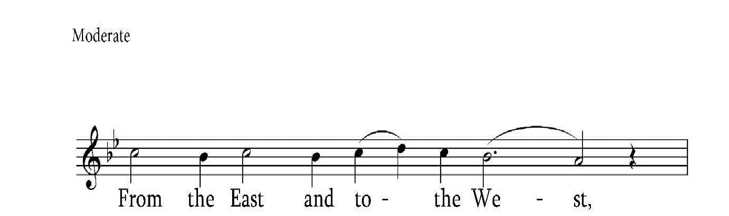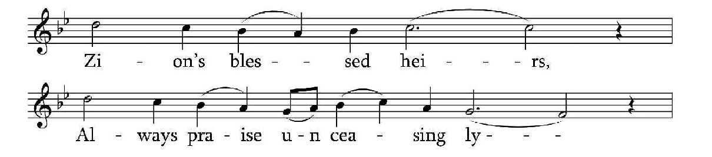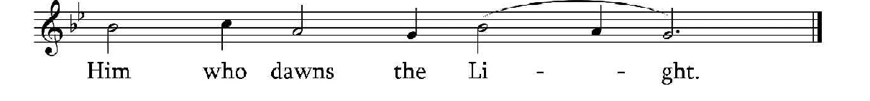

C/ A From the East and to the West, Zion's blessed heirs,
Always praise unceasingly Him who dawns the Light.

Churches of the righteous ones, All who honour him,
Glorify the One who gave Meaning to the light.

St Nersess the Graciotts

Litany
R From Sunrise in the East to Sunset in the West, and throughout the entire Christian world, wherever people call on the name of the Lord in holiness - by their prayers and intercession may the Lord have mercy on us. Let us beseech God to deliver us from sin and from the temptations of the world. May the Lord accept the vows and supplications of our hearts and count us worthy of his faith and his commandments together with all of his saints. Almighty Lord our God, raise us to life and have mercy on us.
A Raise us to life, 0 Lord.

R (if celebrated in the morning)

That the Lord may usher forth this sunlit morning and guide the day ahead in peace; with faith, let us beseech the Lord.
or

(if celebrated in the evening)
That the Lord may usher forth this coming evening and the night ahead in peace; with faith, let us beseech the Lord.
A Grant it, 0 Lord.
R For an angel of peace to be our guardian, let us ask the Lord.
A Grant it, 0 Lord.

R For the pardon and forgiveness of our transgressions, let us ask the Lord.
A Grant it, 0 Lord.
R For the great and mighty power of the holy Cross to help us, let us ask the Lord.
A Grant it, 0 Lord.
R Once again, for our true and holy faith, all together, let us beseech the Lord.
A Lord, have mercy.
R Let us commit ourselves and one another to the almighty Lord our God.
A We commit ourselves to you, 0 Lord.
R Have mercy on us, Lord our God, in your great mercy. Let us all say together as one:
A Lord, have mercy. Lord, have mercy. Lord, have mercy.

Prayer and sharing the peace

L From Sunrise in the East to Sunset in the West, blessed are you,0 Lord, because you are King, and your name is revered throughout the universe. Let our psalmody resound sweetly in your hearing. Let justice dawn from your righteousness and rise over our frailty and may your most holy name be glorified. Let us become worthy to abide by your commandments and to sing praise and glory to the Father and to the Son and to the Holy Spirit, now and always and unto the ages of ages.

A Amen.

The Leader faces the people and may make the sign of the Cross, while saying:

L Peace to all.
A And with your spirit.

The people may exchange a suitable greeting of peace.

R Let us bow down to God.

The people bow down to God in worship, saying:

A Before you, 0 Lord.

L Everlasting God, Eternal God, you dawned as light in this world, and you illumined us from the darkness of our sin. Infinite God, you came into our finite existence, abundantly pouring out the gifts of the Holy Spirit on your creatures. Now and for all eternity you are extolled, most great God, with the Father and the most Holy Spirit, now and always and unto the ages of ages.
A Amen.

Scripture readings
R1 This reading is from the Prophet Isaiah (58:6-11)

Is not this the fast that I choose: to lose the bonds of injustice, to undo the thongs of the yoke, to let the oppressed go free, and to break every yoke? Is it not to share your bread with the hungry, and bring the homeless poor into your house; when you see the naked, to cover them, and not to hide yourself from your own kin? Then your light shall break forth like the dawn, and your healing shall spring up quickly; your vindicator shall go before you, the glory of the Lord shall be your rear guard. Then you shall call, and the Lord will answer; you shall cry for help, and he will say, Here I am. If you remove the yoke from among you, the pointing of the finger, the speaking of evil, if you offer your food to the hungry and satisfy the needs of the afflicted, then your light shall rise in the darkness and your gloom be like noonday. The Lord will guide you continually, and satisfy your needs in parched places, and make your bones strong; and you shall be like a watered garden, like a spring of water, whose waters never fail.

R2 This reading is from the Letter of the Apostle Paul to the Ephesians. (4:1-13)

I, therefore, the prisoner in the Lord, beg you to walk in a manner worthy of the calling to which you have been called, with all humility and gentleness, with patience, bearing with one another in love, making every effort to maintain the unity of the Spirit in the bond of peace: there is one body and one Spirit, just as you were called to the one hope of your calling, one Lord, one faith, one baptism, one God and Father of all, who is above all and through all and in all. But each of us was given grace according to the measure of Christ's gift. Therefore, it is said, ''When he ascended on high, he made captivity itself a captive; he gave gifts to his people." (When it says, "He ascended," what does it mean but that he had also descended into the lower parts of the earth? He who descended is the same one who ascended far above all the heavens, so that he might fill all things.) He himself granted that some are apostles, prophets, evangelists, pastors and teachers to equip the saints for the work of ministry, for building up the body of Christ, until all of us come to the unity of the faith and of the knowledge of the Son of God, to maturity, to the measure of the full stature of Christ.

C/ A (chanted) Alleluia. Alleluia.
For with you is the fountain of life; in your light we see light.

R Alleluia. Rise to your feet.

The Leader faces the people and may make the sign of the Cross, while saying:
L Peace to all.
A And with your spirit.

R Listen attentively to the holy Gospel of Jesus Christ according to John. (12:31-36)
C Glory to you, Lord our God.

R Attention! God is speaking.

Jesus said to the crowd: 'Now is the judgement of this world; now the ruler of this world will be driven out. And I, when I am lifted up from the earth, will draw all people to myself.' He said this to indicate the kind of death he was to die. The crowd answered him, 'We have heard from the law that the Messiah remains for ever. How can you say that the Son of Man must be lifted up? Who is this Son of Man?' Jesus said to them, 'The light is with you for a little longer. Walk while you have the light, so that the darkness may not overtake you. If you walk in the darkness, you do not know where you are going. While you have the light, believe in the light, so that you may become children of light.'

C/ A Glory to you, our Lord Jesus Christ.

Sermon/Homily Prayer
R Gracious Lord, God of all,
Guide for the lost, Light for those in darkness. Our eyes turn to you, hear our prayers.
May the sun of your glory shine forth, giving life and light to all, from the East to the West, and from the North to the South. Let the morning rays of your eternal spring awaken us who await your coming.

0 Jesus Christ, Light from the Light, dwell within us, who have come together to worship your holy and precious name. Let your life-giving radiance kindle within us a deeper love for one another. May your brilliant light stir us to ever more flourishing unity. Like diverse flowers in the garden of your Kingdom, may your divine brilliance cause us to bloom in harmony. And so, all as one, may we always joyfully praise and glorify you, and the Father and the Holy Spirit, now and always and unto the ages of ages. Amen.

Adapted from St Gregory of Narek

Responsorial psalm

The two sides of the assembly recite or chant verses of the psalm alternately, with all/joining together in the response. As the psalm is being recited/ chanted, candies are distributed to the people.
R Our eyes turn to you,0 God of all. Have mercy on us and hear our prayers.
A Our eyes turn to you,0 God of all. Have mercy on us and hear our prayers.
Side1 The Lord is king. Let the earth rejoice; let the many coastlands be glad!
Side2 Clouds and thick darkness are all around him; righteousness and justice are the foundation of his throne.
A Our eyes turn to you,0 God of all. Have mercy on us and hear our prayers.

Side1 Fire goes before him,
and consumes his adversaries on every side.
Side2 His lightnings light up the world; the earth sees and trembles.
A Our eyes turn to you,0 God of all. Have mercy on us and hear our prayers.

Side1 The mountains melt like wax before the Lord, before the Lord of all the earth.
Side2 The heavens proclaim his righteousness; and all the peoples behold his glory.
A Our eyes turn to you,0 God of all. Have mercy on us and hear our prayers.

Side1 All servants of images are put to shame, those who make their boast in worthless idols; all gods bow down before him.
Side2 Zion hears and is glad, and the towns of Judah rejoice, because of your judgments,0 God.
A Our eyes turn to you,0 God of all. Have mercy on us and hear our prayers.

Side1 For you,0 Lord, are most high over all the earth; you are exalted far above all gods.
Side2 You who love the Lord, hate evil; he guards the lives of his faithful; he rescues them from the hand of the wicked.
A Our eyes turn to you,0 God of all. Have mercy on us and hear our prayers.

Side1 Light dawns for the righteous and joy for the upright in heart.
Side2 Rejoice in the Lord,0 you righteous, and give thanks to his holy name!
A Glory to the Father and to the Son and to the Holy Spirit.
Now and always and unto the ages of ages. Amen.
Psalm 97

Hymn

While the hymn is being sung, two young people holding unlit candles or tapers light them from the central candle and the light is passed to all in the church.

Sing Verse 2 and 3 followed by the Chorus of the Song, “Christ be Our Light.” Repeat where needed.

Creed

L Bathed in the light of the Wisdom of Christ, together, let us confess our common faith.

A We believe in one God, the Father, the Almighty,
maker of heaven and earth,
of all that is, seen and unseen.
We believe in one Lord, Jesus Christ, the only Son of God,
eternally begotten of the Father, Light from Light,
true God from true God, begotten, not made.
of one Being with the Father.
Through him all things were made.
For us all, and for our salvation he came down from heaven;
and was incarnate of the Holy Spirit and the virgin Mary, and was made human.
For our sake he was crucified under Pontius Pilate; he suffered and was buried.
On the third day he rose from the dead in accordance with the scriptures.
He ascended to heaven
and is seated at the right hand of the Father.
He will come again in glory
to judge the living and the dead and his kingdom will have no end. We believe in the Holy Spirit,
the Lord, the giver of life,
who proceeds from the Father.
Who, with the Father and the Son, is worshipped and glorified, who has spoken through the Prophets.
We believe in one, holy, catholic and apostolic Church.
We confess one baptism for the forgiveness of sins. We look forward to the resurrection of the dead, and to life in the age to come. Amen.

Closing prayers

L Again, in peace, let us beseech the Lord.
Let us glorify Almighty God, who has shined his light upon his creatures. Now, may he once more shine his abundant mercy upon those who glorify his name in song. Almighty Lord our God, raise us to life and have mercy on us.

A Lord, have mercy. Lord, have mercy. Lord, have mercy.

Thank everyone and invite to refreshments if organized.

Organizing light refreshments after the service, allows time to mix and mingle with those present from the faith communities.

